PRACTICAL 8 : Temperature Data Logging to ThingSpeak Cloud

Aim : To send temperature sensor data to the ThingSpeak cloud using Arduino and NodeMCU.

Overview :
In this project, a temperature sensor is used to collect data, which is then sent to the ThingSpeak cloud platform using Arduino and NodeMCU. This experiment introduces cloud-based data storage, remote monitoring and IoT communication protocols.

Materials Required :
- Arduino Uno R3
- 2 x 1 kΩ Resistor
- Temperature Sensor (TMP36)
- Wifi Module (ESP8266)
- Jumper Wires
- Arduino IDE (Installed on your Computer)

Circuit Connection and Steps :
- Power Connections :
  - TMP36 VCC → 5V (Arduino), GND → GND (Arduino)
  - ESP8266 VCC & CH_PD → 3.3V (Arduino), GND → GND (Arduino)
- Sensor & ESP8266 Wiring :
  - TMP36 VOUT → A0 (Arduino)
  - ESP8266 TX → RX (Arduino) via 1kΩ resistor
  - ESP8266 RX → TX (Arduino) via voltage divider (two 1kΩ resistors)

Circuit Diagram :
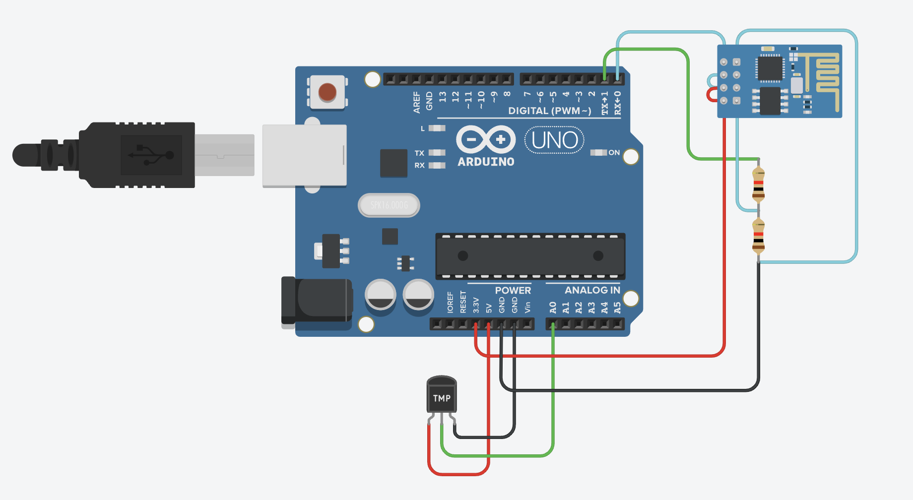
Schematic Diagram :
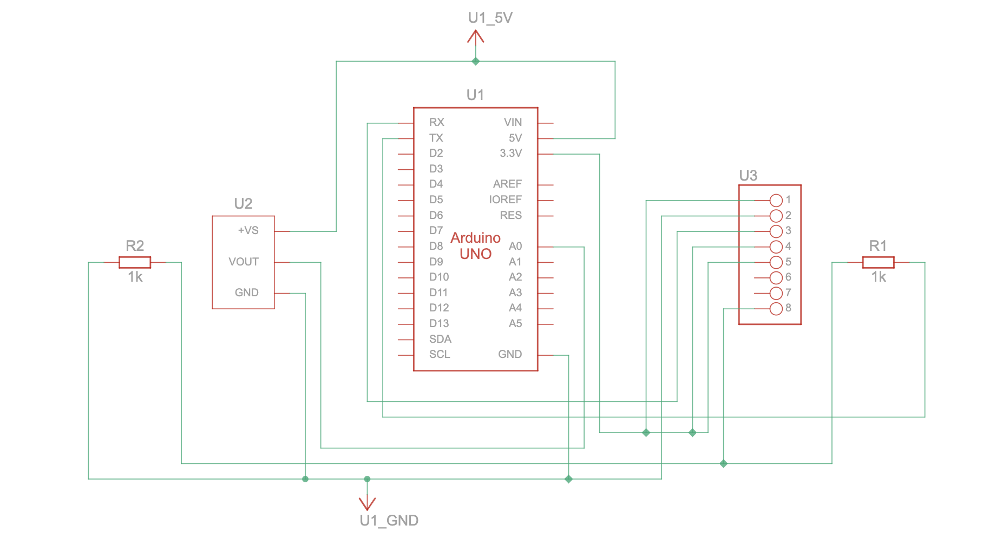

Code :
String ssid = "Simulator Wifi"; // SSID to connect to
String password = ""; // No password in virtual WiFi
String host = "api.thingspeak.com";
const int httpPort = 80;
String apiKey = "6VXJKID8U5GRES8B"; // Your ThingSpeak API key
const int tempPin = A0; // LM35 connected to A0
int setupESP8266(void) {
Serial.begin(115200); // Serial communication with PC
Serial.println("AT");
delay(1000); // Wait for ESP8266 response
if (!Serial.find("OK")) return 1;
// Connect to WiFi
Serial.println("AT+CWJAP=\"" + ssid + "\",\"" + password + "\"");
delay(5000);
if (!Serial.find("OK")) return 2;
// Open TCP connection to ThingSpeak
Serial.println("AT+CIPSTART=\"TCP\",\"" + host + "\"," + httpPort);
delay(2000);
if (!Serial.find("OK")) return 3;
return 0;
}
void sendTemperatureData() {
int sensorValue = analogRead(tempPin);
float temperature = (sensorValue * 5.0 / 1023.0) * 100.0; // LM35 formula
Serial.println("Temperature: " + String(temperature) + "°C");
// Construct HTTP request
String httpPacket = "GET /update?api_key=" + apiKey + "&field1=" + String(temperature) +
" HTTP/1.1\r\nHost: " + host + "\r\n\r\n";
int length = httpPacket.length();
// Send message length
Serial.print("AT+CIPSEND=");
Serial.println(length);
delay(1000);
if (!Serial.find(">")) return;
// Send HTTP request
Serial.print(httpPacket);
delay(2000);
if (!Serial.find("SEND OK")) return;
Serial.println("Data sent to ThingSpeak!");
}
void setup() {
setupESP8266();
}
void loop() {
sendTemperatureData();
delay(1000); // Send data
}

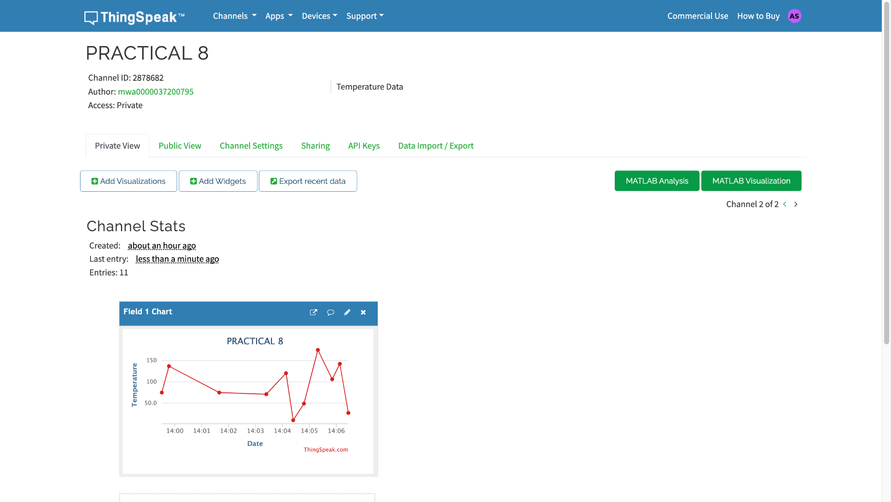
Results :
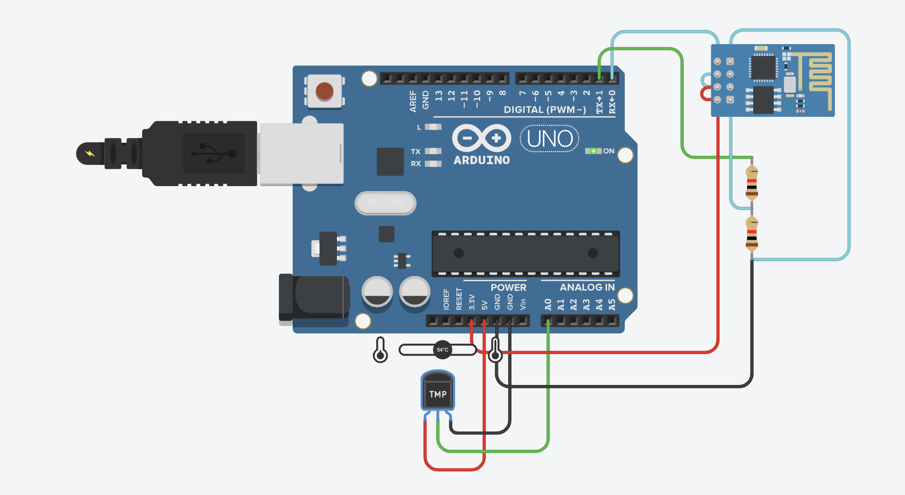

Conclusion :
This project successfully collects and uploads temperature data to the ThingSpeak cloud platform using Arduino and NodeMCU. It introduces cloud-based IoT applications and remote data monitoring, forming the basis for more advanced smart environment solutions and predictive analytics.

